TP MODUL 4

Nama : Ahmad Naufal Ramadhan

NIM : 103012300239

Kelas : IF-47-02

Kode Asprak : YDA

list.h

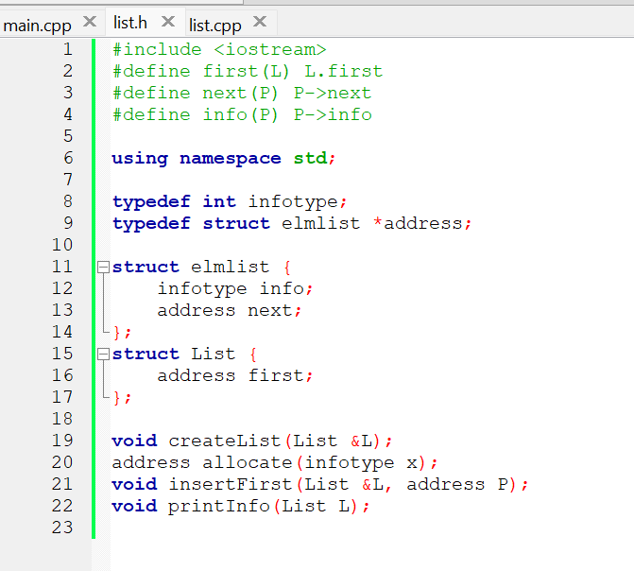

list.cpp

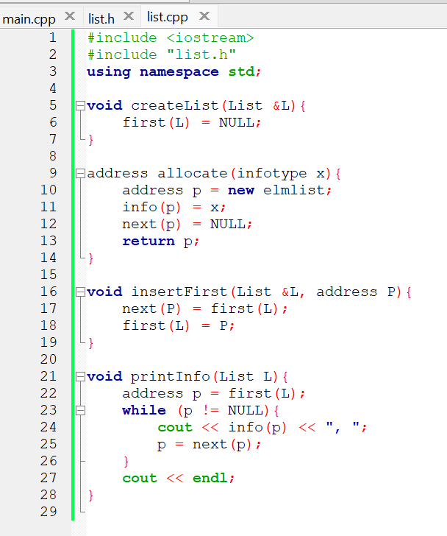

main.cpp

print

NOMOR 7 SESI HAVE FUN



